Table of Contents

- Overview
- Structural Features
- Materials Of Main Components
- Structural Illustration
- Performance Data
- Installation Dimensions
- Start Up And Shut Down
- Operational Instruction

- Overview

  - Application

The CCB type eat hutch slurry pump is developed based on the latest technologies and on experiences of water pump usage in China, and is reliable and easy to maintain. Its life time is much longer than that of screw pump and sump well pump. It is widely used to transfer eat hutch waste slurry, waste water, lipids, etc. Particles sizes up to ¼ of the pump bore size can be transferred due to its anti-clogging structure of large channel. Container type mechanical seal could also be installed for the auxiliary impellers to ensure no leakage while running.

  - Operation Parameters

Rotation rate: 980, 1480, 2950 (r/min)
Voltage: 380 V
Inlet and outlet bore size: 50 – 300 mm
Temperature: ≤ 150 ℃
Percentage of solid in the slurry: ≤ 25%

  - Nomenclature of Model Name

An example model name, 100CCB90-25, is used to explain its nomenclature:

100 --- Inlet and outlet bore size
CCB --- Eat hutch slurry pump
90 ----- Designed capacity at 90 m³/h
25 ----- Designed head of 25 m
F ------- An auxiliary impeller seal

  - Performance

Capacity: 3 ～720 m³/h
Head: 10 ～100 m

  - Work Conditions

- Temperature ≤ 150 ℃
- Percentage of solid in slurry < 25%
- Viscosity (7 ～23) x 10^{－6}㎡/s
- Density < 1800 kg/m³
- Particle size (diameter) for different bore size (mm)
Bore size | 50 | 65 - 80 | 100 - 125 | 150 - 200 | 250 -300
Particle size | < 10 | < 20 | < 25 | < 30 | < 50

- Structural Features

CCB eat hutch slurry pump has the following technical advantages:

- The impeller is of semi-open type, which increases pumping efficiency by 10 ～15% compared with those traditional screw pump or sump well pump, hence the motor power needed could be one grade down which will in return save energy consumption. Furthermore, the impeller is more cavitation-resistant.
- The sealing system consists of auxiliary impeller sealing and power-off sealing based on a serial of fluid power, and is designed for frequent start/stop usage.
- The pump is linked directly to the motor. The impeller rotates clockwise when viewed from the motor end.
- There is a special desilting case at the bottom of the pump to collect precipitants which cannot be discharged from the outlet but could be removed through the door on the case.

- Materials Of Main Components

Pump body | Impeller | Shaft | Sealing ring | Auxiliary Impeller | Bearing Spider | Base Plate for Motor
1Cr18Ni9Ti | Cr26 alloy | 1Cr18Ni9Ti | Cr26 alloy | 1Cr18Ni9Ti | 1Cr18Ni9Ti | Q235-A

- Structural Illustration
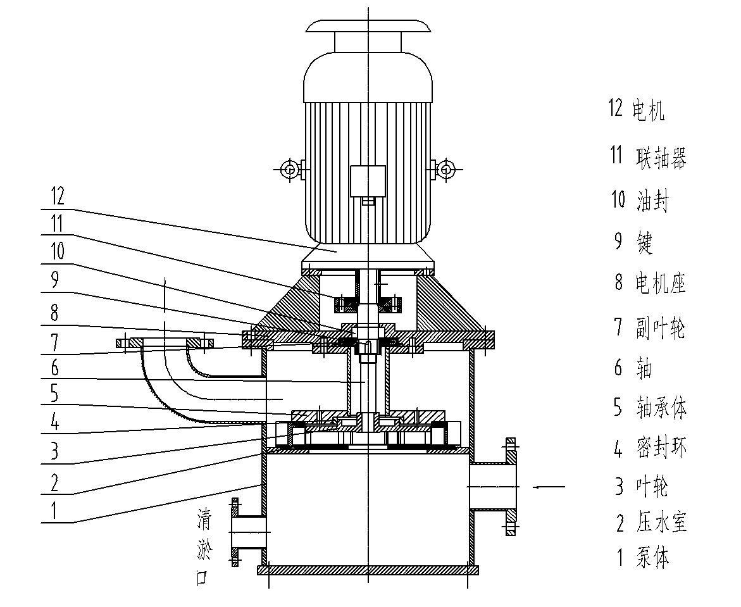

- Pump body 2. Pressurized water chamber 3. Impeller 4. Sealing ring 5. Bearing spider
6. Shaft 7. Auxiliary impeller 8. Base plate for motor 9. Key 10. Oil sealing 11. Coupling
12. Motor

- Performance Data

Data  Model | Capacity | Head | Rotation rate | Power of Shaft | Associated Motor |  | Efficiency  (η) | (NPSH)r  (m) | Unit Weight  (kg)
 |  |  |  |  | Power | Model
 | m³/h | m | r/min | kw | kw |  | % | m | kg
50CCB8-20 | 6.4  8  9.6 | 21  20  19 | 2950 | 0.81  0.91  0.92 | 4 | Y112M-2 | 45  48  54 | 3.0  3.0  3.5 | 200
65CCB8-50 | 6.4  8  9.6 | 53  50  48 | 2950 | 2.0  2.2  2.3 | 5.5 | Y132M-2 | 47  50  55 | 3.0  3.0  3.5 | 250
65CCB10-20 | 8  10  12 | 21  20  19 | 1480 | 0.96  1.1  1.2 | 5.5 | Y132S-4 | 48  51  55 | 3.0  3.0  3.5 | 240
100CCB30-25 | 24  30  36 | 26  25  24 | 1480 | 2.6  3.0  3.4 | 7.5 | Y132M-4 | 65  68  70 | 3.0  3.0  3.0 | 350
125CCB150-25 | 90  150  180 | 30  25  20.6 | 2950 | 12.9  15.3  16.0 | 22 | Y180-2 | 57  67  63 | 4.7  5.2  5.7 | 570
125CCB135-32 | 80  135  160 | 36  32  28 | 2950 | 13.3  18.1  19.7 | 30 | Y200L1-2 | 59  65  62 | 4.7  5.2  5.7 | 630
150CCB180-25 | 108  180  216 | 27.2  25  23.2 | 1480 | 13.6  18.3  21.0 | 30 | Y200L-4 | 59  67  65 | 3.5  4.0  4.5 | 920
150CCB200-32 | 120  200  240 | 34  32  29 | 1480 | 18.5  25.6  28.7 | 37 | Y225S-4 | 60  68  66 | 3.5  4.0  4.5 | 970
200CCB300-25 | 180  300  360 | 28  25  22 | 1480 | 21.8  28.8  31.3 | 37 | Y225S-4 | 63  71  69 | 3.8  4.3  4.8 | 1150
200CCB270-32 | 162  270  324 | 35.2  32  27.8 | 1480 | 25.9  34.6  37.2 | 45 | Y225M-4 | 60  68  66 | 3.8  4.3  4.8 | 1280
250CCB550-25 | 330  550  630 | 27.1  25  22 | 1480 | 37.9  50.6  53.2 | 75 | Y280S-4 | 64  74  71 | 5.0  5.5  6.0 | 1860
250CCB500-32 | 300  500  570 | 37.3  32  28.5 | 1480 | 48.4  59.7  61.5 | 75 | Y280S-4 | 63  73  72 | 5.0  5.5  6.0 | 1950
300CCB650-22 | 390  650  750 | 25  22  20 | 980 | 42.2  53.4  56.8 | 75 | Y315S-6 | 63  73  72 | 4.0  4.5  5.0 | 2530

- Installation Dimensions
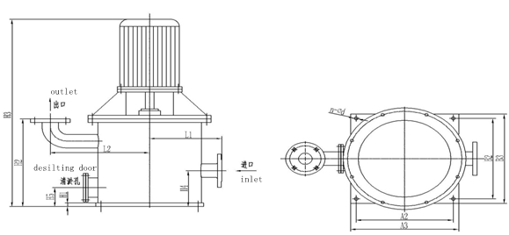

Model | L1 | L2 | H1 | H2 | H3 | H4 | H5 | A2 | A3 | B2 | B3 | n-φd
50CCB8-20 | 335 | 460 | 20 | 490 | 1050 | 200 | 105 | 450 | 500 | 450 | 500 | 4-φ18
65CCB8-50 | 335 | 460 | 20 | 490 | 1050 | 200 | 105 | 450 | 500 | 450 | 500 | 4-φ18
65CCB10-20 | 335 | 460 | 20 | 490 | 1055 | 200 | 105 | 450 | 500 | 450 | 500 | 4-φ18
100CCB30-25 | 335 | 460 | 20 | 537 | 1140 | 200 | 105 | 450 | 500 | 450 | 500 | 4-φ18
125CCB150-25 | 335 | 460 | 20 | 550 | 1310 | 200 | 105 | 450 | 500 | 450 | 500 | 4-φ18
125CCB135-32 | 335 | 460 | 20 | 550 | 1420 | 200 | 105 | 450 | 500 | 450 | 500 | 4-φ18
150CCB180-25 | 430 | 530 | 25 | 630 | 1430 | 220 | 125 | 550 | 600 | 550 | 600 | 4-φ18
150CCB200-32 | 430 | 530 | 25 | 630 | 1530 | 220 | 125 | 550 | 600 | 550 | 600 | 4-φ18
200CCB300-25 | 430 | 570 | 25 | 780 | 1580 | 220 | 150 | 550 | 600 | 550 | 600 | 4-φ18
200CCB270-32 | 430 | 610 | 25 | 780 | 1650 | 220 | 150 | 550 | 600 | 550 | 600 | 4-φ18
250CCB550-25 | 450 | 680 | 25 | 970 | 1830 | 250 | 180 | 580 | 630 | 580 | 630 | 4-φ18
250CCB500-32 | 450 | 730 | 25 | 970 | 1830 | 250 | 180 | 580 | 630 | 580 | 630 | 4-φ18
300CCB650-22 | 450 | 840 | 25 | 1150 | 2360 | 250 | 180 | 580 | 630 | 580 | 630 | 4-φ18

Suction and discharge flange |  |  |  |  |  |  | Flange on desilting case
DN | D1 | D2 | D3 | b | f | n-φd | DN | D1 | D2 | D3 | b | f | n-φd
50 | φ99 | φ125 | φ165 | 20 | 3 | 4-φ18 | 100 | φ114 | φ136 | φ160 | 20 | 3 | 6-φ12
65 | φ118 | φ145 | φ185 | 20 | 3 | 4-φ18 | 100 | φ114 | φ136 | φ160 | 20 | 3 | 6-φ12
100 | φ156 | φ180 | φ220 | 22 | 3 | 8-φ18 | 100 | φ114 | φ136 | φ160 | 20 | 3 | 6-φ12
150 | φ211 | φ240 | φ285 | 24 | 3 | 8-φ22 | 150 | φ199 | φ225 | φ265 | 20 | 3 | 8-φ18
200 | φ266 | φ295 | φ340 | 24 | 3 | 8-φ22 | 200 | φ254 | φ280 | φ320 | 22 | 3 | 8-φ18
250 | φ319 | φ350 | φ395 | 26 | 3 | 12-φ22 | 250 | φ309 | φ335 | φ375 | 24 | 3 | 12-φ18
300 | φ370 | φ400 | φ445 | 26 | 4 | 12-φ22 | 300 | φ363 | φ395 | φ440 | 24 | 3 | 12-φ22

- Start Up And Shut Down

- Before starting up, check and confirm the rotation direction of the motor is correct and it rotates smoothly.
- Before starting up, make sure the vacuum gauge and pressure gauge are off. Switch them on when eat hutch slurry is transferred normally.
- Before starting up, open the exhaust valve or outlet valve to 1/3 position so that gas could be vented during self-suction, and then adjust them to their working positions when eat hutch slurry is transferred normally.
- Before shutting down the machine, make sure that the outlet valve is already switched off.

- Operational Instruction

- The pump should be filled with eat hutch slurry before the first start. No filling is necessary for subsequent use.
- If there are crystals/precipitants in the slurry, the pump should be emptied through the draining door if not used for a long time. If used once for a few days, the pump should be switched on for 10 min every 24 hrs to reduce the accumulation of crystals/precipitants.
- Please make sure that exhaust valve is open when there is bubbles or there is big static fluid column pressure during waste transferring, so that it could accelerate venting out gas and shorten the time of self-suction. When the pump is in automatic mode, an automatic exhaust valve should be installed between the pump and the outlet valve.
- The pump should be run strictly within its specifications (like capacity, head and the absorption). The exceeding its capacity will cause cavitation and damages on the motor.
- Make sure the bearing is well lubricated. Replenish or replace it with No. 3 lithium base grease when 2-pole motor runs over 2000 hrs, 4-pole and 6-pole motors over 4000 hrs.
- For outdoor usage in winter time, the pump should be kept warm after shut down. Otherwise, empty the pump to prevent frost crack.

