JLZ series high efficiency slurry circulation pump

Attention
§ Please read the manual carefully and follow the instructions for installation, operation and maintenance.
§ The manual should be kept by the end user(s).
§ The manufacturer reserves the right to change technical specifications without further notice.

1. Structural Features And Design Highlights

JLZ series high efficiency slurry circulation pump is a new generation of product and was developed based on our successful JLNZ series pump, absorbing the advanced technology of similar products in the market and taking into account the specific conditions and requirement of the slurry pump employed in the solar energy silicon material industry. It is suitable to transfer the slurry when the PH value is 2.5~3.5, slurry specific gravity ≤ 2 g/cm³ , temperature range 4°C – 100°C.

Slurry circulation pump, which is a critical device in silicon slicing system, has stringent requirement on its reliability, performance and life time. It must be highly efficient, wear-resistant and cavitation resistant, all of which are directly reflected on its hydraulic design, structural design and material of components in the flow path.

JLZ’s pump case, pump cover and other components in the flow path are made of Cr26 material with its impeller, impeller nut and back retaining ring in SS304 material.

JLZ’s hydraulic system is designed based on the technique of the solid-liquid two-phase flow pump put forward by famous Professor Du of Sichuan University and further adjusted through CAD and CFD. JLZ’s structure is shown in Figure 1.
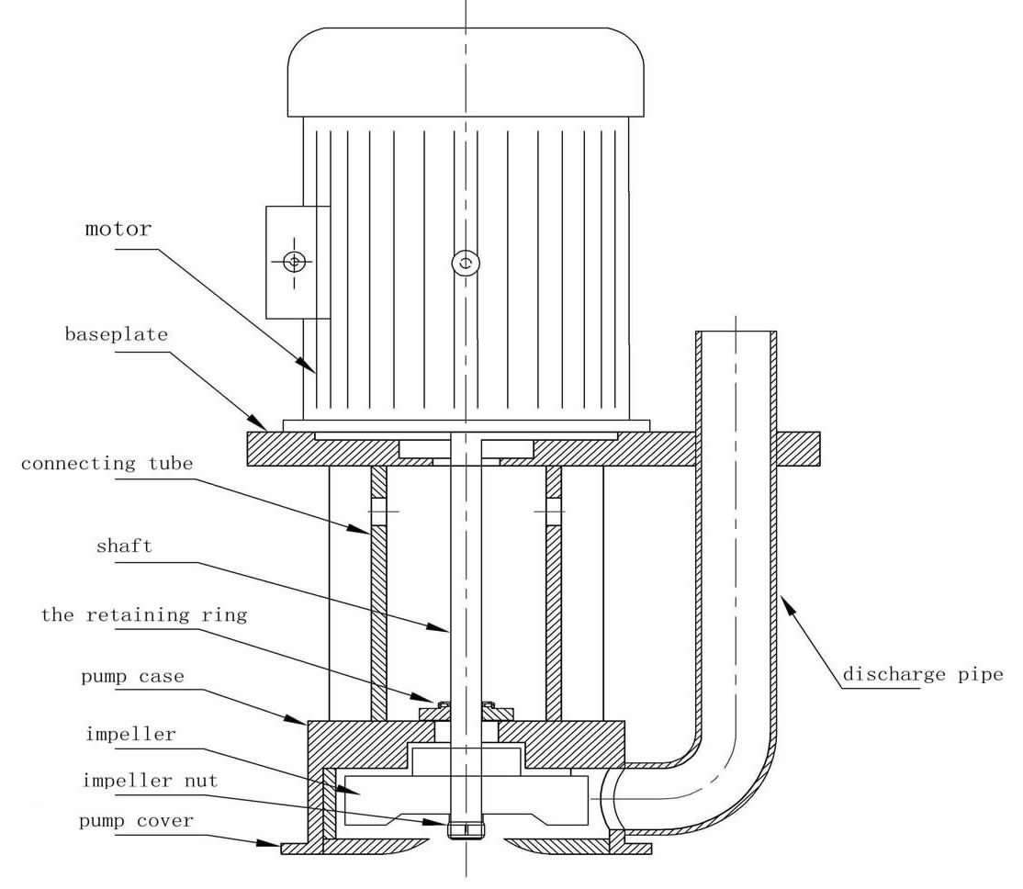

1.1 Structural Features

(a) The pump is of single-stage single-suction vertical centrifugal type with open impeller. This structure is practically proven to be suitable for circulating pump of the highly concentrated and highly abrasive slurry in the recovery pond of silicon slicing system.
(b) There is no O-ring sealing for the impeller and the pump case, as the O-ring sealing would have been eroded quickly by the slurry and the pumping efficiency would have been reduced quickly due to it.
(c) The pump is axially adjustable. High efficiency could always be maintained by adjusting the clearance between the impeller and the front end pump cover.
(d) The motor employs a thrust bearing to undertake the axial thrust. The bearing is lubricated with grease. The rubber sealing is used in the bearing box to prevent water and other substance from going inside.
(e) The pump and motor share one shaft with large diameter and short head, which will reduces the shaft’s vibration, hence increasing the pump’s reliability.

1.2 Design highlights

Overview
Back sliding out design: the whole shaft can be pulled out from the motor side. Compared with traditional coupling type shaft, it does not only make it easier to maintain but also increase the reliability because single shaft ensures coaxial rotation.

Front sliding out design: the wear-resisting plate and impeller can be disassembled from the pump’s inlet side. The pump height underneath the installation plate can be adjusted per customer’s requirement.

Pump case
The pump has sufficient size to bear the pressure. Cr26 is used and machined on a whole piece. Special treatment for anti-abrasion has been done on the volute part. Tangent flow direction can be ensured.

Impeller
Impeller is made of SS304 material. The impeller could be remachined and blades could be replaced if eroded. The front blades are placed in a lower position to prevent large particles from entering the space between the impeller and wear-resisting plate. The clearance between the front blade and impeller is increased to reduce the fluid’s flow rate , so as to reduce the abrasion and prevent the cavitation from happening. The blades have balance whole to vent gas and reduce axial thrust.
Bearing
Bearing is imported from NSK or SKF, which has the reputation of long smooth running period. The shaft extension end is sealed with high quality oil to prevent fluid from going into the bearing under any circumstances.

Shaft Sealing
Retaining ring is designed with optimal clearance, making it possible to discharge the air/gas without any negative impact on the pump’s efficiency.
Slurry Circulation Pump Performance Datasheet
Model | Capacity (m³/h) | Head (m) | Rotation rate (rpm) | Associated motor Power (kW)
JLZ6-10 | 6 | 10 | 2900 | 2.2
JLZ8-10 | 8 | 10 | 2900 | 4
JLZ120-10 | 12 | 10 | 2900 | 7.5
Note: The listed above hydraulic models could be customized per clients’ requirement.

2. Technical Specification

Capacity: 4 ~ 500 m³/h
Head: 5 ~ 30 m
Temperature: 4 ~ 100 °C
Power supply voltage: Three-phase 220 V or 380 V

3. Nomenclature of Pump Models

The model name, JLZ8 – 10, is used as an example:
JLZ ----- Vertical slurry circulation pump
8 ------- Designed Capacity
10 ------ Designed Head

Note: There is no motor power specification given in the model name as power varies slightly when slurry gravity changes.

4. Safety Instruction

This safety instruction covers installation, operation and maintenance. Before the installation and the handover, engineers and trained operators should read and understand fully the safety instructions.

4.1 Non-compliance of safety instruction

Any non-compliance of safety instruction could endanger the operators and cause damages to the surroundings and the equipment.
Here are a few bad consequences of non-compliance of security instruction:
o Major fault of the equipment and malfunction of the system.
o Faults which needs maintenance
o Electric, machinery, chemical accidents which will endanger personnel.

4.2 Safety instruction of maintenance, repair and installation

The maintenance, repair and installation should be carried out only when the machine is shut down. The procedures defined in the manual must be followed strictly, which is the only way to ensure safety.

The safety instruction for handover should be followed during the procedure of the handover to users.

4.3 Unauthorized modification and manufacturing of spare parts

Modification of the equipment must be authorized by the manufacturer. The spare parts supplied by the manufacturer should be kept safely. The user is responsible for any damage caused by un-authorized spare parts used.

4.4 The Limitation of Operational Conditions

Under all circumstances, the machine should be operated within the parameter ranges listed in the data sheet.

5. Storage

5.1 Temporary storage
Special attention should be paid to components made of low alloy. Please refer to the manual of machine operation and transportation for storage conditions.
5.2 Storage of the equipment before installation
5.3 Anti-moisture
5.4 No pressure or heavy weight object allowed on the motor fan

6. Open Box Inspection

The following inspection shall be performed when the pump is received.

(a) Check and confirm the specification of the model, capacity and head listed on the machine plate correspond to those in the order.
(b) Check and confirm the pump material specified in the certificate is consistent with the order .
(c) Check and confirm there is no damage to the machine and spare parts.
(d) Check and confirm all the supplied items have arrived: pump, base plate, motor, discharging pipe.

7. On-site Installation
7.1 Acceptance of Pump Foundation
Re-inspect the size and location of the pump foundation in accordance with the pump’s installation drawings. The steel plate around the installation hole at the slurry recovery pond shall have sufficient strength to ensure the compliance of the relevant standards and the installation safety.
The foundation surface around the steel plate embedment shall be flattened.
7.2 Equipment Setting and Leveling
Use the gradienter on the foundation surface to ensure the level. Both tolerance of horizontal and longitudinal levelness are 0.1mm/m. Screw down nuts and then re-check the level.
7.3 Pipe Connection
Attention: It is forbidden to support the pipe by the case of the pump. Exceeded pipe pressure is not allowed. The pipe should be fixed nearby the pump. Besides, please make sure no stress or no strain is passed to the pump through the connecting part. The nominal diameter of pipe should be at least equal to that of inlet and outlet flange.
It is recommended to install an exhaust valve at the high point of the discharge pipe.
The check valve should also be installed at the discharge pipe to prevent the reverse flow.
Appropriate measures should be taken to make up the thermal expansion of the pipe.
7.4 Power Supply
Qualified electrical professionals are required for the power supply. The power capacity should be sufficient in accordance with the motor capacity as shown on the motor name plate and the proper connection should be considered. It’s strongly recommended that a motor protection switchgear shall be provided.

8. Handover, Startup And Shutdown
8.1 Recheck the Installation of Pump Before Startup
(1) Pump is installed correctly.
(2) The pump rotation direction is correct
(3) The pipe layout is reasonable
(4) The power supply and circuit connection are correct
(5) Auxiliary piping installation is correct
(6) Motor grounding is correct, and leakage protection is to be provided.
8.2 Work Before Startup
(1) Jigger: It should be smooth, no clash
(2) Check the rotation direction. The rotation direction must be in accord with the direction of the arrow marked on the pump. If the rotation direction is wrong, there will be no fluid pumped out. What’s worse, it will cause vibration and overheating, which will damage the shaft sealing and the pump case.
(3) Prepare the slurry and make sure that the flow path are unimpeded before startup.
8.3 Startup
The pump startup has the following procedures:
(1) Prepare the slurry to be transferred. The slurry height in the recovery pond shall meet the minimum height requirement of the pump submerged depth.
(2) Check the rotation direction, and make sure it is accord with the mark on the pump.
(3) Restart
The pump shall not be restarted immediately after shutdown.
8.4 Shutdown
The following procedure for shutdown needs to be followed.
(1) Close the gate valve at the pump outlet
(2) Switch off the power
(3) It is very necessary to empty and clean the pipe with water if the pump is going to stop working for over24 hours in case of slurry solidification and blockage of the pipeline.
8.5 Operation Limits
(1) The temperature limits of the working fluid and its ambient environment
Unless given the consent in written form from the manufacturer, please make sure that the pump runs within the temperature range stated in the pump datasheet or the name plate. Otherwise, the manufacturer will not take any responsibility for the loss.
(2) The density of the working fluid
The input power of the pump shall be in proportion to the density of the working fluid. In order to avoid the overload of the motor, the density of the working fluid should be within the stated specification.
8.6 Storage
Each pump will go through rigorous testing after being assembled and before ex-work. And we recommend that the following measures should be taken for storage if the pump is going to be left for a long time before put into use.
(1) New Pump Storage
Please provide an indoor preservation for the new pump and please keep it dry. The maximum storage life could be 12 months.
(2) The Installed Pump
For those pumps which have been installed in the slurry recovery pond, please start the machine every week and regularly, or make the pump run once every month and it should last for 5 minutes for each time so as to avoid the slurry condensing.

9. Maintenance
9.1 Attention
Please make sure that the power is off during maintenance and the power wouldn’t be switched on accidently.
9.2 Maintenance/Repair
(1) Operational Supervision
a. After starting up the machine, please keep an eye on the reading of the gauges. Please check whether the heating of the motor, the pump vibration and the noise are in normal state or not. Please take immediate corrective actions if any abnormal phenomenon is found.
b. The pump should be stationary all through the work.
c. The bearing should be replaced or lubricated in time.
(2) The Replacement Of The Lubricant
The bearing should be lubricated with the good quality grease which should not be inferior to lithium base grease, and a replacement cycle is 8000 hours.
9.3 Disassembly
Before disassemble the pump, please make sure that the power will not be switched on accidently.
9.4 Re-installation
Please clean up all the parts and check if there is any abrasion or not. Replace those worn parts with the original spares. Besides, install the sealing gasket correctly.
Before installation, please brush all the connecting parts with graphite powder or other similar substance, and all the bolts should be screwed up.

10. Assembly and Disassembly
Make sure the power will not be switched on accidently before disassembly.
10.1 Preparation
(1) Cut the power off and close the pump discharge valve and auxiliary pipe valves.
(2) Empty the fluid in the pump.
(3) Remove the auxiliary pipeline, the instrument as well as the connection bolts on the inlet pipe
(4) Lock the axial position of the retaining ring.
10.2 Disassembly
(1) Disassembly of suction cover: screw off the nut bolt on the flange with inner hexagon spanner.
(2) Disassembly of the impeller: prior to take out the impeller, please dismantle the impeller nuts and washer in sequence. Don't lose the impeller key.
(3) Disassembly of the retaining ring: lock the axial position of the retaining ring and its gap to the pump first, and then loosen the stopper screw.
(4) Screw off the bolts between the motor and the mounting plate, and lift up the motor out of the mounting plate ( please do not bend the extended shaft)
10.3 Assembly of Pump
The assembly of pump is in the reverse order of disassembly.
Attention: If the slide retainer is used to install the retaining ring, please dismantle it after installation and preserve it.

11. Trouble Shooting
Problems | Cause of Problems | Solutions
No fluid out | 1.the height of the fluid in the recovery pond is not enough  2. Wrong rotation direction  3.The impeller and outlet pipe is blocked  4. The actual head/piping pressure drop is higher than the pump head. | 1.Add the fluid in the recovery pond to meet the required height  2.Correct the direction.  3.Remove the blockage.  4.rechoose the model of the pump and increase its rotation speed.
Insufficient flow rate | 1.The severe abrasion and corrosion of the impeller  2.The actual requirement of the flow rate is bigger than the pump capacity | 1. replace the impeller  2.rechoose the model of the pump and increase its rotation speed
Flow rate is over expectation | The actual requirement of head is less than that of pump. | Turn down the outlet valve, change the pump, reduce the rotation speed or cut the impeller to make its diameter smaller
Overload current | 1.The current capacity is over the range of the application.  2. The density of the transferred fluid is too big. | 1.Check the chosen model, and change the range of the capacity. 2.Replace the motor with more powerful one.
Overheating of bearing | 1.The lubricating grease is degraded.  2.The bearing is damaged. | 1. Replace the grease  2.Replace the bearing
Too much noise | 1.The bearing is damaged.  2.The abrasion /corrosion of the impeller  3. The shaft is bent | 1. Replace the bearing  2.Replace the impeller  3.Replace the shaft or straight shaft

